**CMPE-281 CLOUD TECHNOLOGIES**



***LAB 2 ASSIGNMENT***

**NAME: KIRAN MOHARE**

**ID: 009179209**

Submitted to:

**Prof. Mike Larkin**

**SNAPSHOTS:**

* 1. **Starting the application:**

Step 1: Start the application from command line

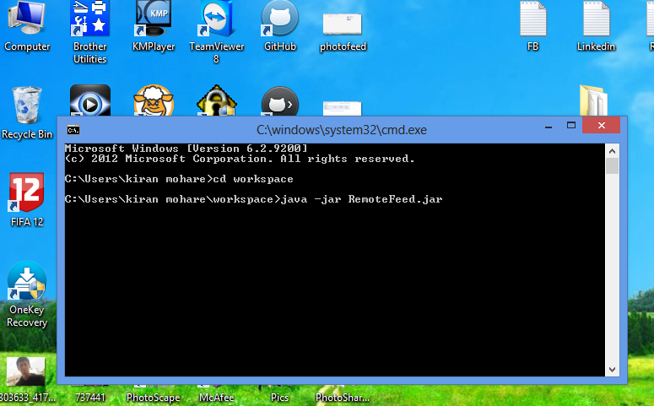

Step 2: Navigate to the image folder and select multiple files to upload

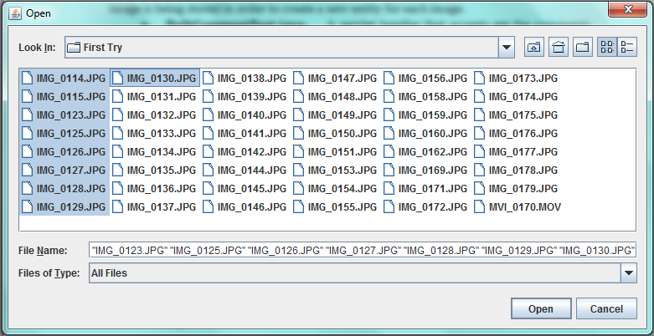

Step 3: Get the comment.xml file

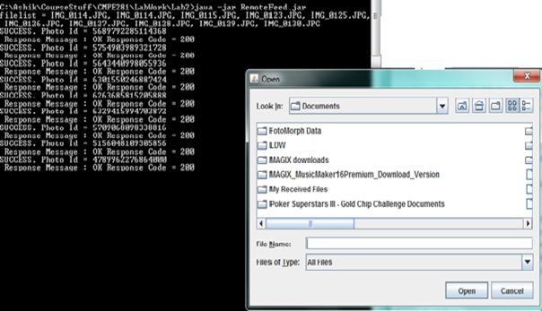

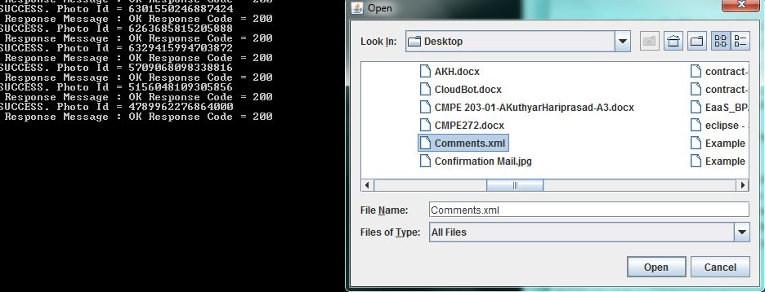

Step 4: Uploading comments to the correct images from the image file.

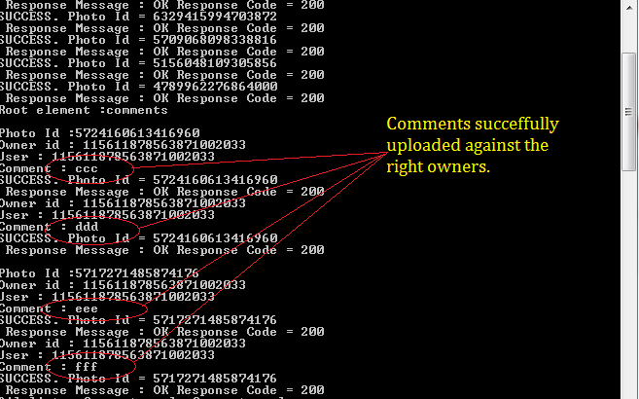

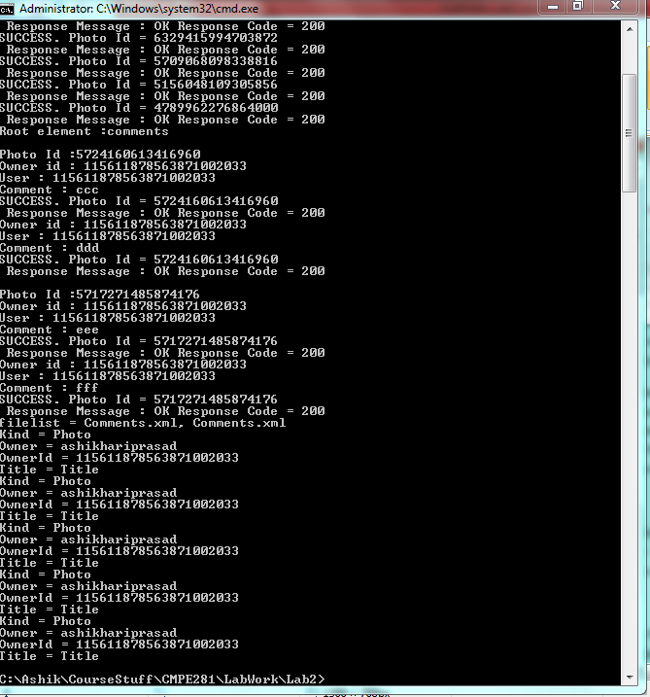

Google SDK downloaded from the following site.

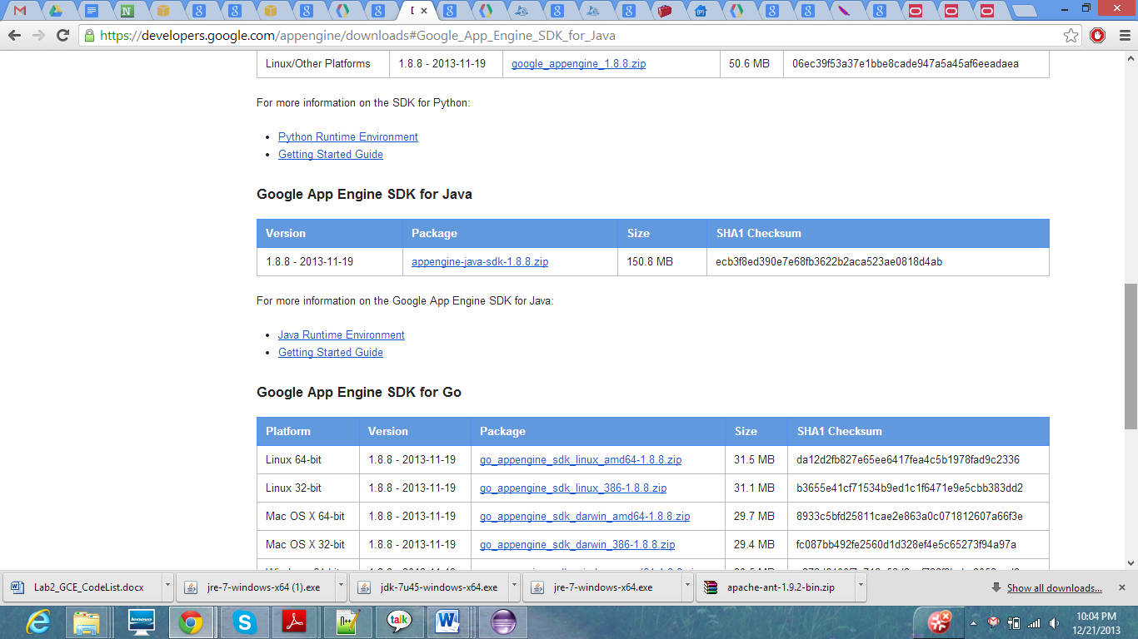

Photofeed Application :

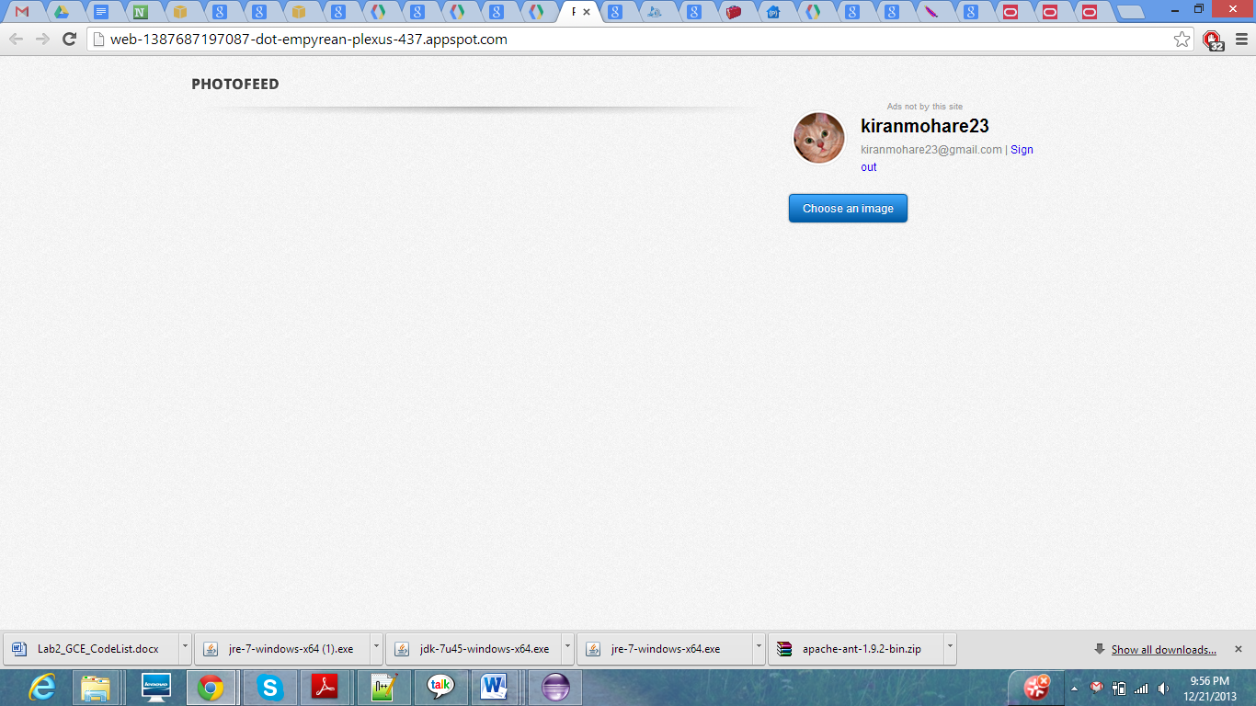

Google App engine Screenshot:

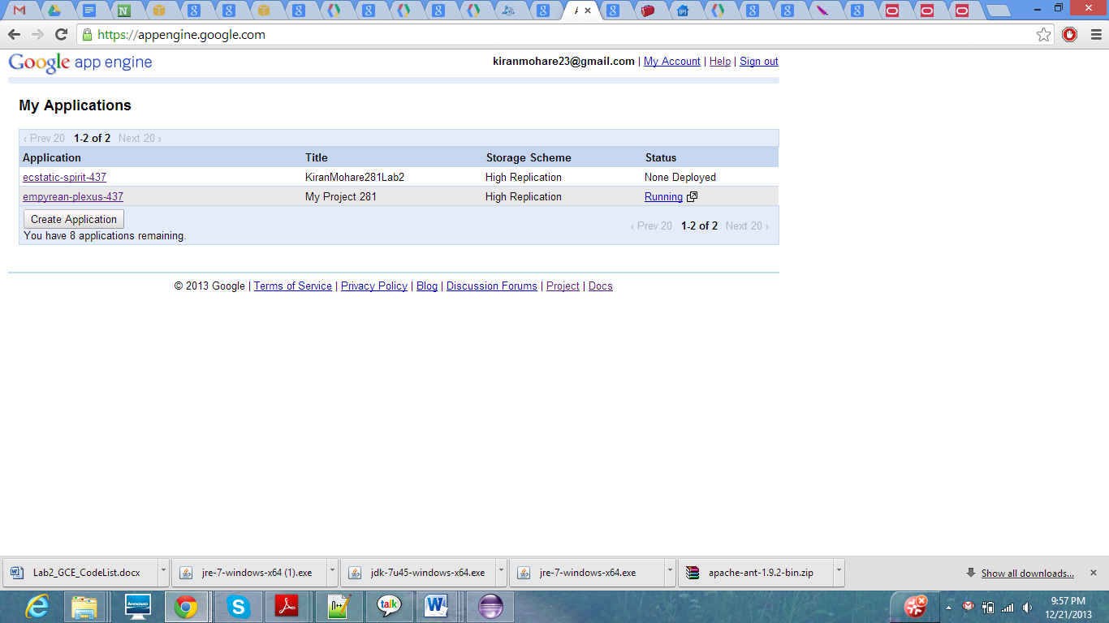

ID Generated In Datastore views:

